> ##Reading the dataset

> german_credit<-read.csv("german.csv", header=TRUE)

> library(rattle)

> names(german_credit)<-normVarNames(names(german_credit))

>

> ##Structure of dataframe

> str(german_credit)

'data.frame': 1000 obs. of 21 variables:

$ status_of_existing_checking_account : Factor w/ 4 levels "A11","A12","A13",..: 1 2 4 1 1 4 4 2 4 2 ...

$ duration_in_month : int 6 48 12 42 24 36 24 36 12 30 ...

$ credit_history : Factor w/ 5 levels "A30","A31","A32",..: 5 3 5 3 4 3 3 3 3 5 ...

$ purpose : Factor w/ 10 levels "A40","A41","A410",..: 5 5 8 4 1 8 4 2 5 1 ...

$ credit_amount : int 1169 5951 2096 7882 4870 9055 2835 6948 3059 5234 ...

$ savings_account_bonds : Factor w/ 5 levels "A61","A62","A63",..: 5 1 1 1 1 5 3 1 4 1 ...

$ present_employment_since : Factor w/ 5 levels "A71","A72","A73",..: 5 3 4 4 3 3 5 3 4 1 ...

$ installment_rate_in_percentage_of_disposable_income : int 4 2 2 2 3 2 3 2 2 4 ...

$ personal_status_and_sex : Factor w/ 4 levels "A91","A92","A93",..: 3 2 3 3 3 3 3 3 1 4 ...

$ other_debtors_guarantors : Factor w/ 3 levels "A101","A102",..: 1 1 1 3 1 1 1 1 1 1 ...

$ present_residence_since : int 4 2 3 4 4 4 4 2 4 2 ...

$ property : Factor w/ 4 levels "A121","A122",..: 1 1 1 2 4 4 2 3 1 3 ...

$ age_in_years : int 67 22 49 45 53 35 53 35 61 28 ...

$ other_installment_plans : Factor w/ 3 levels "A141","A142",..: 3 3 3 3 3 3 3 3 3 3 ...

$ housing : Factor w/ 3 levels "A151","A152",..: 2 2 2 3 3 3 2 1 2 2 ...

$ number_of_existing_credits_at_this_bank : int 2 1 1 1 2 1 1 1 1 2 ...

$ job_status : Factor w/ 4 levels "A171","A172",..: 3 3 2 3 3 2 3 4 2 4 ...

$ number_of_people_being_liable_to_provide_maintenance_for: int 1 1 2 2 2 2 1 1 1 1 ...

$ telephone : Factor w/ 2 levels "A191","A192": 2 1 1 1 1 2 1 2 1 1 ...

$ foreign_worker : Factor w/ 2 levels "A201","A202": 1 1 1 1 1 1 1 1 1 1 ...

$ default_status : int 0 1 0 0 1 0 0 0 0 1 ...

>

> ##Data exploration

> summary(german_credit)

status_of_existing_checking_account duration_in_month credit_history purpose credit_amount

A11:274 Min. : 4.0 A30: 40 A43 :280 Min. : 250

A12:269 1st Qu.:12.0 A31: 49 A40 :234 1st Qu.: 1366

A13: 63 Median :18.0 A32:530 A42 :181 Median : 2320

A14:394 Mean :20.9 A33: 88 A41 :103 Mean : 3271

3rd Qu.:24.0 A34:293 A49 : 97 3rd Qu.: 3972

Max. :72.0 A46 : 50 Max. :18424

(Other): 55

savings_account_bonds present_employment_since installment_rate_in_percentage_of_disposable_income

A61:603 A71: 62 Min. :1.000

A62:103 A72:172 1st Qu.:2.000

A63: 63 A73:339 Median :3.000

A64: 48 A74:174 Mean :2.973

A65:183 A75:253 3rd Qu.:4.000

Max. :4.000

personal_status_and_sex other_debtors_guarantors present_residence_since property

A91: 50 A101:907 Min. :1.000 A121:282

A92:310 A102: 41 1st Qu.:2.000 A122:232

A93:548 A103: 52 Median :3.000 A123:332

A94: 92 Mean :2.845 A124:154

3rd Qu.:4.000

Max. :4.000

age_in_years other_installment_plans housing number_of_existing_credits_at_this_bank

Min. :19.00 A141:139 A151:179 Min. :1.000

1st Qu.:27.00 A142: 47 A152:713 1st Qu.:1.000

Median :33.00 A143:814 A153:108 Median :1.000

Mean :35.55 Mean :1.407

3rd Qu.:42.00 3rd Qu.:2.000

Max. :75.00 Max. :4.000

job_status number_of_people_being_liable_to_provide_maintenance_for telephone foreign_worker

A171: 22 Min. :1.000 A191:596 A201:963

A172:200 1st Qu.:1.000 A192:404 A202: 37

A173:630 Median :1.000

A174:148 Mean :1.155

3rd Qu.:1.000

Max. :2.000

default_status

Min. :0.0

1st Qu.:0.0

Median :0.0

Mean :0.3

3rd Qu.:1.0

Max. :1.0

>

> credit_integer<-subset(german_credit,select = c( default_status,

+ duration_in_month,

+ credit_amount,

+ installment_rate_in_percentage_of_disposable_income,

+ present_residence_since,

+ age_in_years,

+ number_of_existing_credits_at_this_bank,

+ number_of_people_being_liable_to_provide_maintenance_for

+ ))

>

>

> names<-names(credit_integer)

> names<-as.list(names)

> ##Descriptive statistics

> descriptive <- function(x,y)

+ {

+ hist(x, col="red", main="Histogram ")

+ boxplot(x, col="yellow", main="Boxplot")

+ qqnorm(x, col="green", main= "QQ plot")

+ plot(density(x), col="blue", main="Density plot")

+ title(y, outer=TRUE)

+ }

>

> par(mfrow=c(2,2), oma=c(0,0,1,0))

> mapply(descriptive,credit_integer,names)

$default_status

NULL

$duration_in_month

NULL

$credit_amount

NULL

$installment_rate_in_percentage_of_disposable_income

NULL

$present_residence_since

NULL

$age_in_years

NULL

$number_of_existing_credits_at_this_bank

NULL

$number_of_people_being_liable_to_provide_maintenance_for

NULL

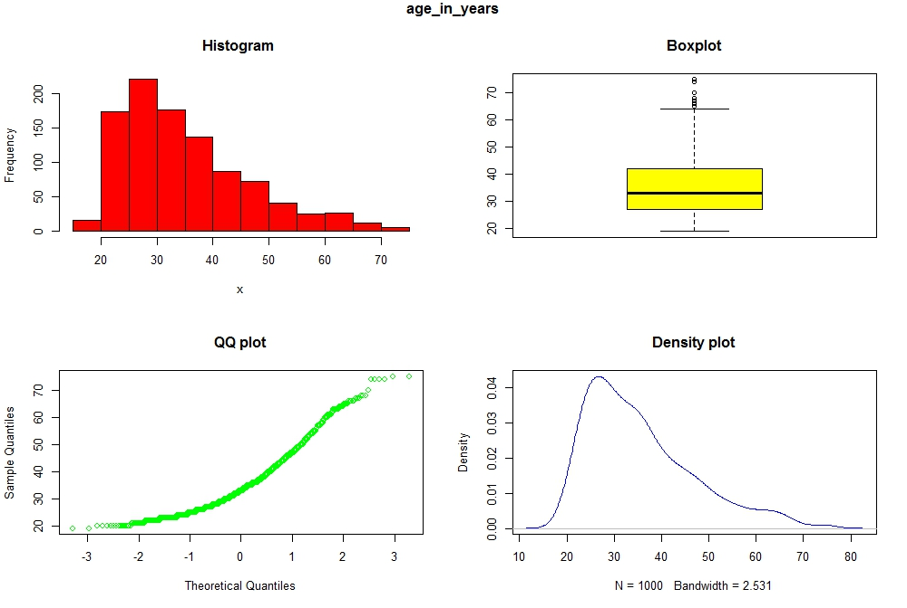

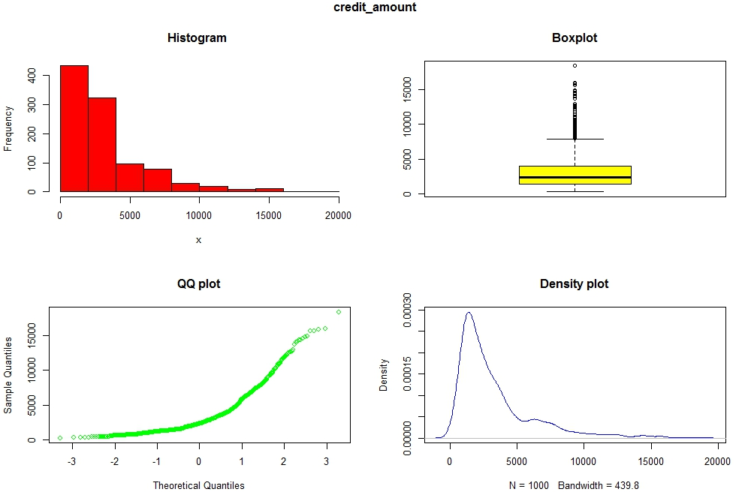

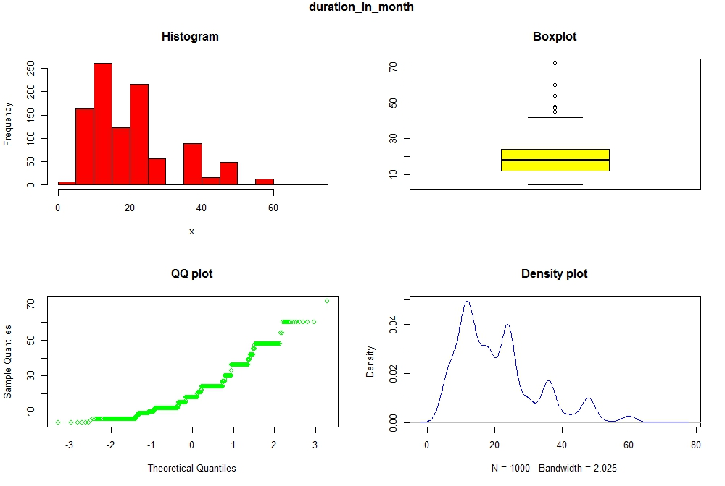

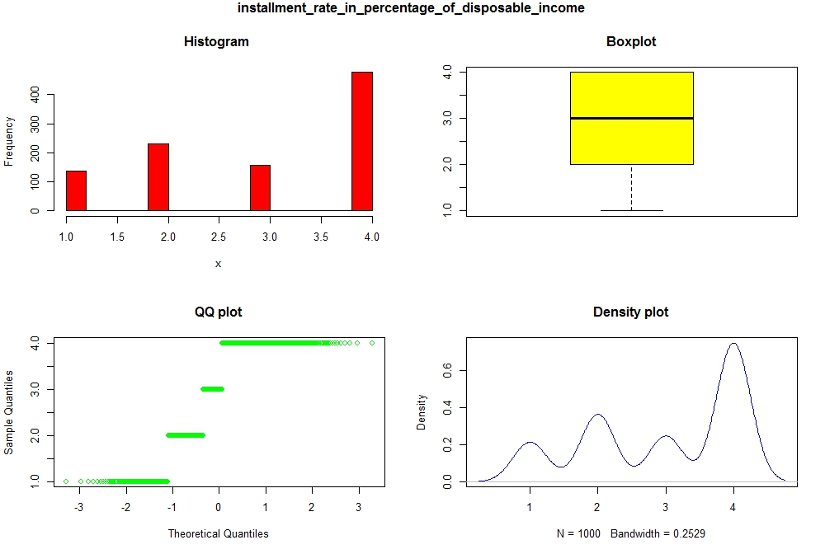

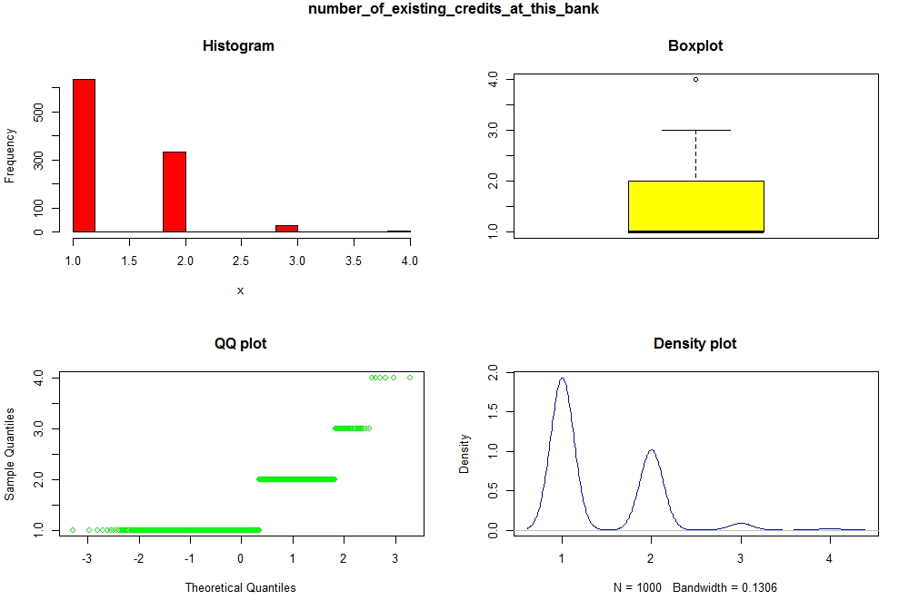

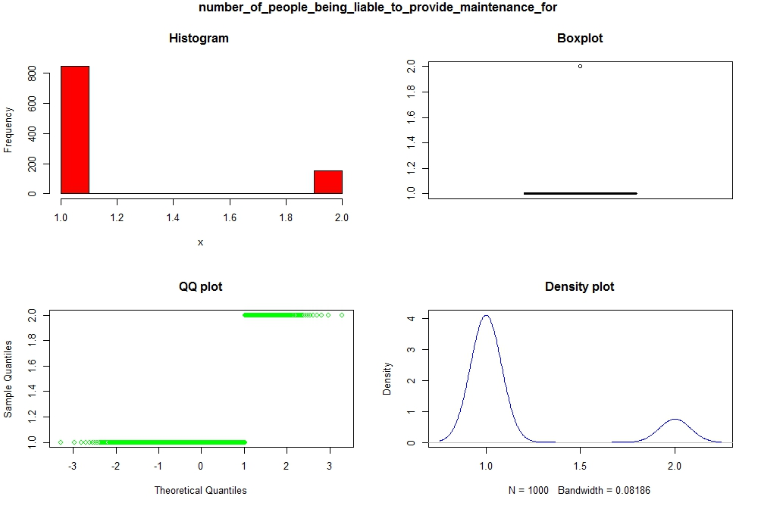

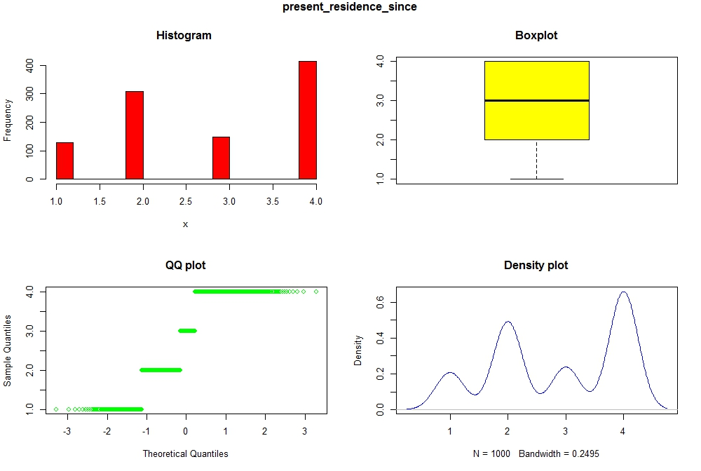

> ##Dummy variable

> dummy_eca<-model.matrix(~status_of_existing_checking_account, german_credit)[,-1]

> dummy_ch<-model.matrix(~credit_history, german_credit)[,-1]

> dummy_p<-model.matrix(~purpose, german_credit)[,-1]

> dummy_sab<-model.matrix(~savings_account_bonds, german_credit)[,-1]

> dummy_pms<-model.matrix(~present_employment_since, german_credit)[,-1]

> dummy_psas<-model.matrix(~personal_status_and_sex, german_credit)[,-1]

> dummy_odg<-model.matrix(~other_debtors_guarantors, german_credit)[,-1]

> dummy_ppt<-model.matrix(~property, german_credit)[,-1]

> dummy_oip<-model.matrix(~other_installment_plans, german_credit)[,-1]

> dummy_h<-model.matrix(~housing, german_credit)[,-1]

> dummy_js<-model.matrix(~job_status, german_credit)[,-1]

> dummy_fw<-model.matrix(~foreign_worker, german_credit)[,-1]

> dummy_npbl<-model.matrix(~number_of_people_being_liable_to_provide_maintenance_for, german_credit)[,-1]

>

> data<-cbind(credit_integer,dummy_eca,dummy_ch,

+ dummy_p, dummy_sab,dummy_pms, dummy_psas,dummy_odg, dummy_ppt,

+ dummy_oip, dummy_h, dummy_js,dummy_fw, dummy_npbl )

> ##Data split

> library(caret)

> set.seed(100)

>

> train<-createDataPartition(y=data$default_status, p = .70,list = FALSE)

> training<-data[train,]

> testing<-data[-train,]

> model<-glm(default_status ~ ., data=training ,family=binomial(link='logit'))

> summary(model)

Call:

glm(formula = default_status ~ ., family = binomial(link = "logit"),

data = training)

Deviance Residuals:

Min 1Q Median 3Q Max

-2.5236 -0.7253 -0.3737 0.7383 2.6140

Coefficients: (1 not defined because of singularities)

Estimate Std. Error z value Pr(>|z|)

(Intercept) -3.058e-01 1.330e+00 -0.230 0.81808

duration_in_month 2.924e-02 1.101e-02 2.655 0.00793 **

credit_amount 1.363e-04 5.187e-05 2.627 0.00861 **

installment_rate_in_percentage_of_disposable_income 3.190e-01 1.048e-01 3.043 0.00234 **

present_residence_since -3.098e-02 1.034e-01 -0.299 0.76456

age_in_years -8.570e-03 1.118e-02 -0.766 0.44349

number_of_existing_credits_at_this_bank 1.018e-01 2.294e-01 0.444 0.65721

number_of_people_being_liable_to_provide_maintenance_for 3.670e-01 2.943e-01 1.247 0.21237

status_of_existing_checking_accountA12 -5.145e-01 2.635e-01 -1.953 0.05088 .

status_of_existing_checking_accountA13 -1.004e+00 4.300e-01 -2.335 0.01954 *

status_of_existing_checking_accountA14 -1.742e+00 2.741e-01 -6.355 2.08e-10 ***

credit_historyA31 3.858e-01 7.084e-01 0.545 0.58604

credit_historyA32 -1.788e-02 5.762e-01 -0.031 0.97524

credit_historyA33 -3.134e-01 6.297e-01 -0.498 0.61870

credit_historyA34 -1.132e+00 5.901e-01 -1.919 0.05503 .

purposeA41 -9.287e-01 4.482e-01 -2.072 0.03829 *

purposeA410 -1.280e+00 8.670e-01 -1.476 0.13985

purposeA42 -5.128e-01 3.021e-01 -1.697 0.08964 .

purposeA43 -7.589e-01 2.982e-01 -2.545 0.01093 *

purposeA44 -5.155e-01 7.979e-01 -0.646 0.51823

purposeA45 1.366e-01 6.885e-01 0.198 0.84271

purposeA46 6.471e-01 4.668e-01 1.386 0.16568

purposeA48 -7.921e-01 1.234e+00 -0.642 0.52096

purposeA49 -3.104e-01 4.017e-01 -0.773 0.43966

savings_account_bondsA62 -4.730e-01 3.440e-01 -1.375 0.16911

savings_account_bondsA63 -3.668e-01 4.707e-01 -0.779 0.43583

savings_account_bondsA64 -1.038e+00 5.742e-01 -1.807 0.07073 .

savings_account_bondsA65 -7.608e-01 3.099e-01 -2.455 0.01408 *

present_employment_sinceA72 -7.125e-01 5.219e-01 -1.365 0.17226

present_employment_sinceA73 -5.367e-01 5.029e-01 -1.067 0.28590

present_employment_sinceA74 -1.320e+00 5.397e-01 -2.446 0.01443 *

present_employment_sinceA75 -7.163e-01 5.039e-01 -1.422 0.15517

personal_status_and_sexA92 -8.834e-03 4.784e-01 -0.018 0.98527

personal_status_and_sexA93 -7.635e-01 4.737e-01 -1.612 0.10702

personal_status_and_sexA94 -4.579e-01 5.574e-01 -0.821 0.41140

other_debtors_guarantorsA102 9.098e-01 4.776e-01 1.905 0.05678 .

other_debtors_guarantorsA103 -1.286e+00 5.499e-01 -2.339 0.01932 *

propertyA122 3.423e-01 3.052e-01 1.121 0.26211

propertyA123 4.380e-01 2.817e-01 1.555 0.11994

propertyA124 9.518e-01 5.000e-01 1.904 0.05694 .

other_installment_plansA142 -3.154e-01 4.804e-01 -0.657 0.51147

other_installment_plansA143 -7.070e-01 2.786e-01 -2.537 0.01117 *

housingA152 -3.154e-01 2.768e-01 -1.139 0.25452

housingA153 -7.393e-01 5.597e-01 -1.321 0.18657

job_statusA172 1.034e+00 8.172e-01 1.265 0.20582

job_statusA173 6.924e-01 7.872e-01 0.880 0.37910

job_statusA174 3.115e-01 7.660e-01 0.407 0.68426

dummy_fw -7.170e-01 8.162e-01 -0.878 0.37972

dummy_npbl NA NA NA NA

---

Signif. codes: 0 ‘***’ 0.001 ‘**’ 0.01 ‘*’ 0.05 ‘.’ 0.1 ‘ ’ 1

(Dispersion parameter for binomial family taken to be 1)

Null deviance: 883.54 on 699 degrees of freedom

Residual deviance: 643.32 on 652 degrees of freedom

AIC: 739.32

Number of Fisher Scoring iterations: 5

> model_F<-glm(formula = default_status ~ duration_in_month + credit_amount +

+ installment_rate_in_percentage_of_disposable_income + status_of_existing_checking_accountA12 +

+ status_of_existing_checking_accountA13 + status_of_existing_checking_accountA14 +

+ credit_historyA34 + purposeA43 +

+ purposeA46 + savings_account_bondsA65 +

+ present_employment_sinceA74 + personal_status_and_sexA93 +

+ other_debtors_guarantorsA102 +

+ other_debtors_guarantorsA103 + other_installment_plansA143,

+ family = binomial(link = "logit"), data = training)

>

> summary(model_F)

Call:

glm(formula = default_status ~ duration_in_month + credit_amount +

installment_rate_in_percentage_of_disposable_income + status_of_existing_checking_accountA12 +

status_of_existing_checking_accountA13 + status_of_existing_checking_accountA14 +

credit_historyA34 + purposeA43 + purposeA46 + savings_account_bondsA65 +

present_employment_sinceA74 + personal_status_and_sexA93 +

other_debtors_guarantorsA102 + other_debtors_guarantorsA103 +

other_installment_plansA143, family = binomial(link = "logit"),

data = training)

Deviance Residuals:

Min 1Q Median 3Q Max

-2.1517 -0.7694 -0.4035 0.8071 2.7863

Coefficients:

Estimate Std. Error z value Pr(>|z|)

(Intercept) -2.875e-01 4.290e-01 -0.670 0.50273

duration_in_month 3.049e-02 1.009e-02 3.021 0.00252 **

credit_amount 1.124e-04 4.633e-05 2.425 0.01530 *

installment_rate_in_percentage_of_disposable_income 2.633e-01 9.737e-02 2.704 0.00686 **

status_of_existing_checking_accountA12 -6.638e-01 2.363e-01 -2.809 0.00497 **

status_of_existing_checking_accountA13 -1.160e+00 4.079e-01 -2.843 0.00447 **

status_of_existing_checking_accountA14 -1.905e+00 2.488e-01 -7.656 1.93e-14 ***

credit_historyA34 -1.087e+00 2.388e-01 -4.552 5.33e-06 ***

purposeA43 -4.900e-01 2.342e-01 -2.092 0.03645 *

purposeA46 1.076e+00 4.163e-01 2.585 0.00975 **

savings_account_bondsA65 -6.662e-01 2.802e-01 -2.377 0.01744 *

present_employment_sinceA74 -6.388e-01 2.766e-01 -2.309 0.02094 *

personal_status_and_sexA93 -6.162e-01 2.009e-01 -3.068 0.00216 **

other_debtors_guarantorsA102 9.089e-01 4.398e-01 2.067 0.03875 *

other_debtors_guarantorsA103 -1.212e+00 5.091e-01 -2.380 0.01729 *

other_installment_plansA143 -6.790e-01 2.299e-01 -2.954 0.00314 **

---

Signif. codes: 0 ‘***’ 0.001 ‘**’ 0.01 ‘*’ 0.05 ‘.’ 0.1 ‘ ’ 1

(Dispersion parameter for binomial family taken to be 1)

Null deviance: 883.54 on 699 degrees of freedom

Residual deviance: 674.25 on 684 degrees of freedom

AIC: 706.25

Number of Fisher Scoring iterations: 5

> vif(model_F)

duration_in_month

1.648814

credit_amount

1.913026

installment_rate_in_percentage_of_disposable_income

1.234368

status_of_existing_checking_accountA12

1.325187

status_of_existing_checking_accountA13

1.136372

status_of_existing_checking_accountA14

1.336276

credit_historyA34

1.049571

purposeA43

1.074941

purposeA46

1.052849

savings_account_bondsA65

1.040355

present_employment_sinceA74

1.046207

personal_status_and_sexA93

1.121364

other_debtors_guarantorsA102

1.022818

other_debtors_guarantorsA103

1.037933

other_installment_plansA143

1.021659

> ##Predicting

>

> training$fit<-predict(model_F, training, type= 'response')

> testing$fit<-predict(model_F, testing, type= 'response')

>

> training$predscore<-ifelse(training$fit>0.5,1,0)

> testing$predscore<-ifelse(testing$fit>0.5,1,0)

> ##Model Diagnostics

> ##HL test

> ##install.packages("Hmisc")

> library(Hmisc)

> omers2(fitted(model_F),training$default_status)

Error: could not find function "omers2"

> par(mfrow=c(1,1))

> plot(residuals(model_F,type="pearson"), main="Pearson Residual Plot")

>

> ##install.packages("ResourceSelection")

> library(ResourceSelection)

> hoslem.test(training$default_status, fitted(model_F))

Hosmer and Lemeshow goodness of fit (GOF) test

data: training$default_status, fitted(model_F)

X-squared = 9.5452, df = 8, p-value = 0.2984

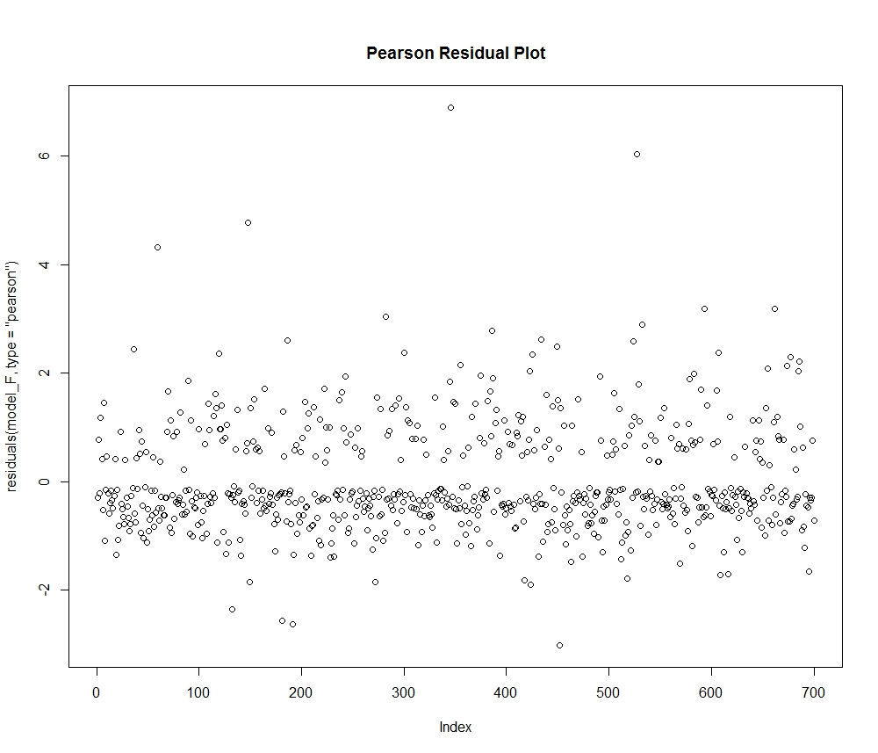

> ##Crosstable

> ##install.packages("gmodels")

> library(gmodels)

> ##Training

> CrossTable(training$default_status, training$predscore,prop.chisq = FALSE,

+ prop.c=FALSE, prop.r=FALSE, dnn=c('actual', 'predected'))

Cell Contents

|-------------------------|

| N |

| N / Table Total |

|-------------------------|

Total Observations in Table: 700

| predected

actual | 0 | 1 | Row Total |

-------------|-----------|-----------|-----------|

0 | 413 | 59 | 472 |

| 0.590 | 0.084 | |

-------------|-----------|-----------|-----------|

1 | 107 | 121 | 228 |

| 0.153 | 0.173 | |

-------------|-----------|-----------|-----------|

Column Total | 520 | 180 | 700 |

-------------|-----------|-----------|-----------|

> ##Testing

> CrossTable(testing$default_status, testing$predscore,prop.chisq = FALSE,

+ prop.c=FALSE, prop.r=FALSE, dnn=c('actual', 'predected'))

Cell Contents

|-------------------------|

| N |

| N / Table Total |

|-------------------------|

Total Observations in Table: 300

| predected

actual | 0 | 1 | Row Total |

-------------|-----------|-----------|-----------|

0 | 194 | 34 | 228 |

| 0.647 | 0.113 | |

-------------|-----------|-----------|-----------|

1 | 36 | 36 | 72 |

| 0.120 | 0.120 | |

-------------|-----------|-----------|-----------|

Column Total | 230 | 70 | 300 |

-------------|-----------|-----------|-----------|

> library(ROCR)

> ##ROC Curve

> ##install.packages("ROCR")

> library(ROCR)

> ##Training

> predTraining<-prediction(training$default_status, training$predscore)

> perfTraining<-performance(predTraining,"tpr", "fpr")

> plot(perfTraining, main="ROC Curve", col = 2,lwd = 2)

> abline(a = 0,b = 1,lwd = 2,lty = 3,col = "black")

> aucTraining<- performance(predTraining,"auc")

> aucTraining

An object of class "performance"

Slot "x.name":

[1] "None"

Slot "y.name":

[1] "Area under the ROC curve"

Slot "alpha.name":

[1] "none"

Slot "x.values":

list()

Slot "y.values":

[[1]]

[1] 0.7332265

Slot "alpha.values":

list()

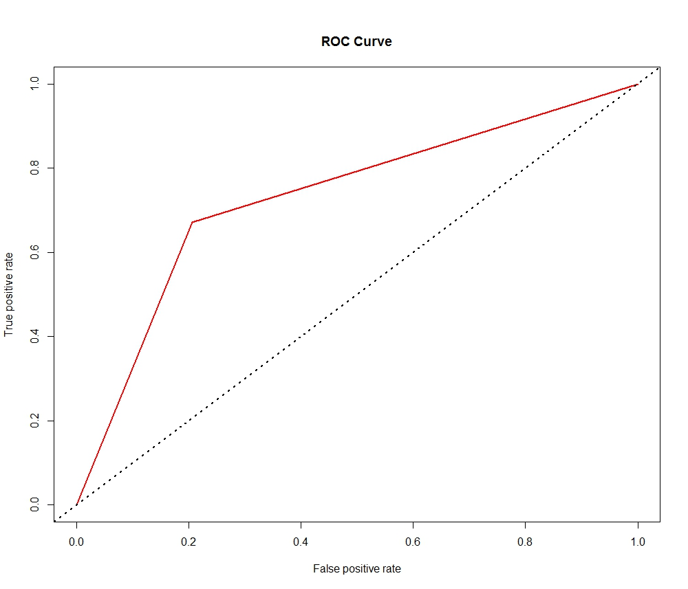

> ##Testing

> predTesting<-prediction(testing$default_status, testing$predscore)

> perfTesting<-performance(predTesting,"tpr", "fpr")

> plot(perfTesting, main="ROC Curve", col = 2,lwd = 2)

> abline(a = 0,b = 1,lwd = 2,lty = 3,col = "black")

> aucTesting<- performance(predTesting,"auc")

> aucTesting

An object of class "performance"

Slot "x.name":

[1] "None"

Slot "y.name":

[1] "Area under the ROC curve"

Slot "alpha.name":

[1] "none"

Slot "x.values":

list()

Slot "y.values":

[[1]]

[1] 0.678882

Slot "alpha.values":

list()

